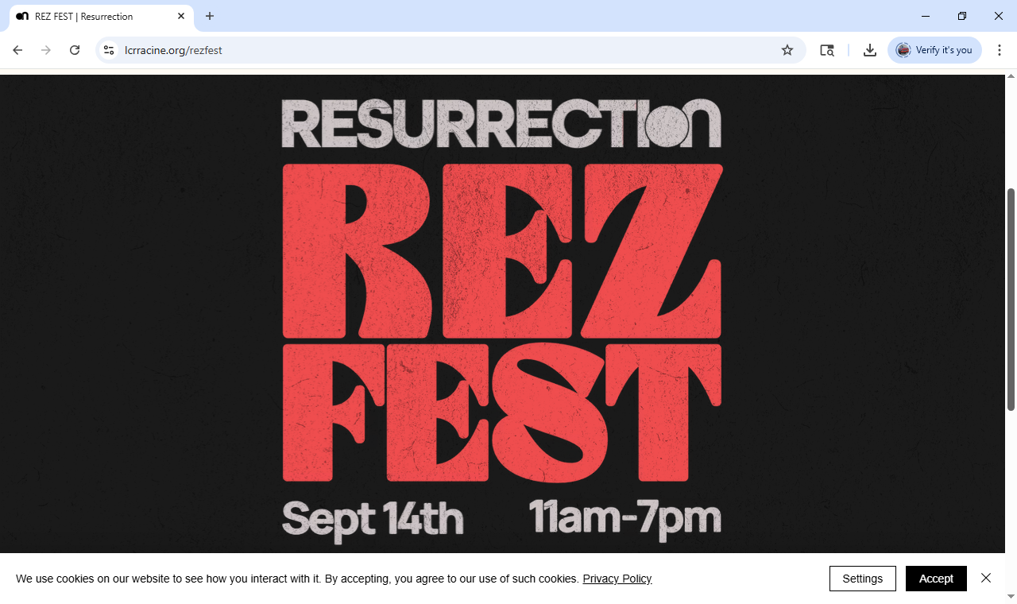RezFest Spotlight

THIS WEEK following both Sunday services there will a *Volunteer Signup and Info Session* in the Family Room just outside of the sanctuary. You will have the opportunity to pick a particular area/task and time slot to volunteer for at RezFest. As planning has proceeded, we now have more defined tasks and volunteer needs for you to choose from.

**Even if you have signed up online, you should still stop in** to have the opportunity to pick your preferred area and specific times.

As a bonus, we will be asking for a preferred shirt size so we can reserve for you, the latest fashion item; ***a stunningly awesome RezFest Staff T-shirt*** for the day of RezFest. Please stop by so you’re sure to get your preferred volunteering time and task.

But don’t worry, there will also be sessions next week July 16th. But your selections may be limited. Thank you for supporting this mission.