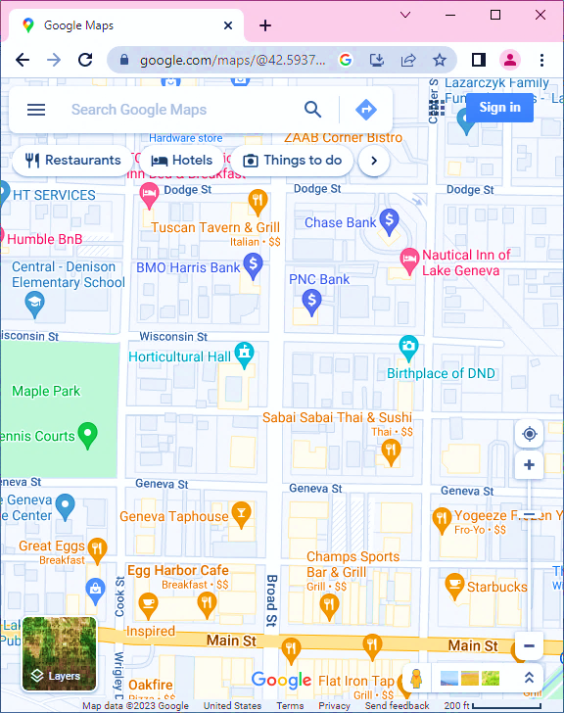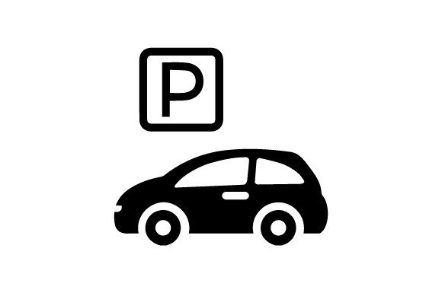

**Horticultural Hall**  
330 Broad Street  
Lake Geneva, WI 53147

**Parking**– on-street  
– BMO bank lot  
 (not in ATM line)  
– School lot  
– Town Bank lot, 2  
 blocks north on  
 Broad Street



**Emily  
&  
Jake’s  
Wedding**

