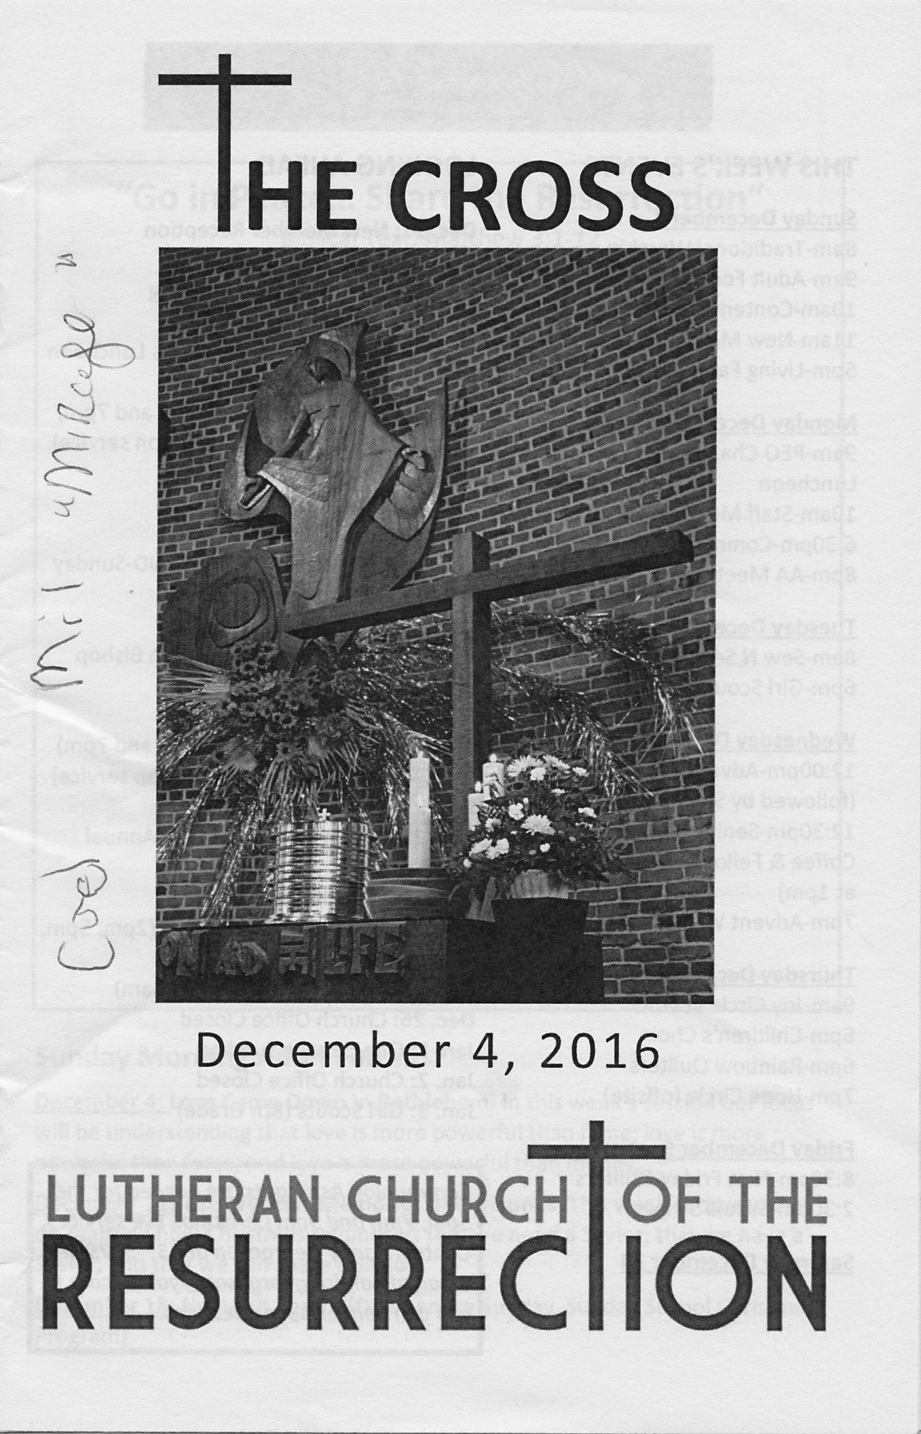 **ENDOWMENT FUND  
Informational Questionnaire**

To help your Endowment Fund Board of Directors better serve you and the church, we need some basic information. This questionnaire is totally anonymous and should take just a minute to answer. Thank you in advance for your help with this important mission.

*Instructions:  
 a) Check the YES or NO box for each question  
 b) Fold the questionnaire in half  
 c) Drop in the offering plate*

|  |  |  |
| --- | --- | --- |
| **PLEASE ANSWER THE FOLLOWING QUESTIONS:** | **YES** | **NO** |
| 1. Did you know that Resurrection has an endowment fund? |  |  |
|  |  |  |
| 1. Would you like to know more about LCR's endowment fund and how it works? |  |  |
|  |  |  |
| 1. Do you have a will or a trust? |  |  |
|  |  |  |
| 1. Would you like more details on how to participate in the LCR Endowment Fund mission? |  |  |
|  |  |  |
| 1. Would you like any other additional information (please note below) ? | | |

** ENDOWMENT FUND  
Informational Questionnaire**

To help your Endowment Fund Board of Directors better serve you and the church, we need some basic information. This questionnaire is totally anonymous and should take just a minute to answer. Thank you in advance for your help with this important mission.

*Instructions:  
 a) Check the YES or NO box for each question  
 b) Fold the questionnaire in half  
 c) Drop in the offering plate*

|  |  |  |
| --- | --- | --- |
| **PLEASE ANSWER THE FOLLOWING QUESTIONS:** | **YES** | **NO** |
| 1. Did you know that Resurrection has an endowment fund? |  |  |
|  |  |  |
| 1. Would you like to know more about LCR's endowment fund and how it works? |  |  |
|  |  |  |
| 1. Do you have a will or a trust? |  |  |
|  |  |  |
| 1. Would you like more details on how to participate in the LCR Endowment Fund mission? |  |  |
|  |  |  |
| 1. Would you like any other additional information (please note below) ? | | |

fs