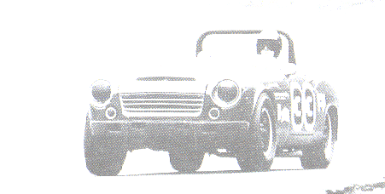    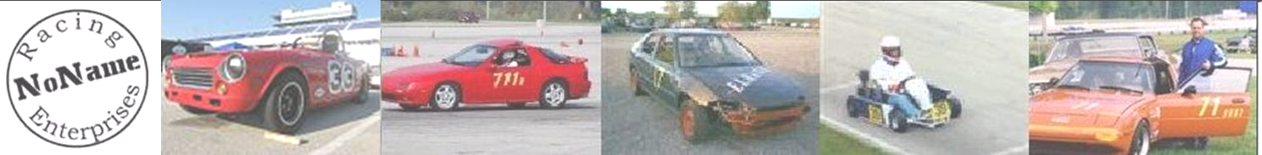  NoName Racing Enterprises  Car: Red 1967 Datsun Roadster 1600  Driver: Steve Jacobson  Crew: Dawn, Emily, Ryan  roadster33@gmail.com  NoNameRacing.com  Vintage racing… for the love of it | NoName Racing Enterprises  Car: Red 1967 Datsun Roadster 1600  Driver: Steve Jacobson  Crew: Dawn, Emily, Ryan  roadster33@gmail.com  NoNameRacing.com  Old cars, Older guys
NoName Racing Enterprises  Car: Red 1967 Datsun Roadster 1600  Driver: Steve Jacobson  Crew: Dawn, Emily, Ryan  roadster33@gmail.com  NoNameRacing.com  Fat guys, Skinny tires | NoName Racing Enterprises  Car: Red 1967 Datsun Roadster 1600  Driver: Steve Jacobson  Crew: Dawn, Emily, Ryan  roadster33@gmail.com  NoNameRacing.com  Vintage racing… for the love of it
NoName Racing Enterprises  Car: Red 1967 Datsun Roadster 1600  Driver: Steve Jacobson  Crew: Dawn, Emily, Ryan  roadster33@gmail.com  NoNameRacing.com  Vintage racing… for the love of it | NoName Racing Enterprises  Car: Red 1967 Datsun Roadster 1600  Driver: Steve Jacobson  Crew: Dawn, Emily, Ryan  roadster33@gmail.com  NoNameRacing.com  Old cars, Older guys
NoName Racing Enterprises  Car: Red 1967 Datsun Roadster 1600  Driver: Steve Jacobson  Crew: Dawn, Emily, Ryan  roadster33@gmail.com  NoNameRacing.com  Fat guys, Skinny tires | NoName Racing Enterprises  Car: Red 1967 Datsun Roadster 1600  Driver: Steve Jacobson  Crew: Dawn, Emily, Ryan  roadster33@gmail.com  NoNameRacing.com  Vintage racing… for the love of it
NoName Racing Enterprises  Car: Red 1967 Datsun Roadster 1600  Driver: Steve Jacobson  Crew: Dawn, Emily, Ryan  roadster33@gmail.com  NoNameRacing.com  Fat guys, Skinny tires | NoName Racing Enterprises  Car: Red 1967 Datsun Roadster 1600  Driver: Steve Jacobson  Crew: Dawn, Emily, Ryan  roadster33@gmail.com  NoNameRacing.com  Old cars, Older guys

